**CSE3506 – ESSENTIALS OF DATA ANALYTICS**

**EXPT NO: 5**

**DATE:** 3rd March 2021

**NAME:** R. Harini

**REG. NO.:** 18BCE1010

**LOGISTIC REGRESSION**

**AIM**

Understand the following operations/functions on ‘CreditWorthiness’ dataset and perform similar operations on ‘CrashTest’ dataset based on given instructions.

**MATLAB PROGRAM**

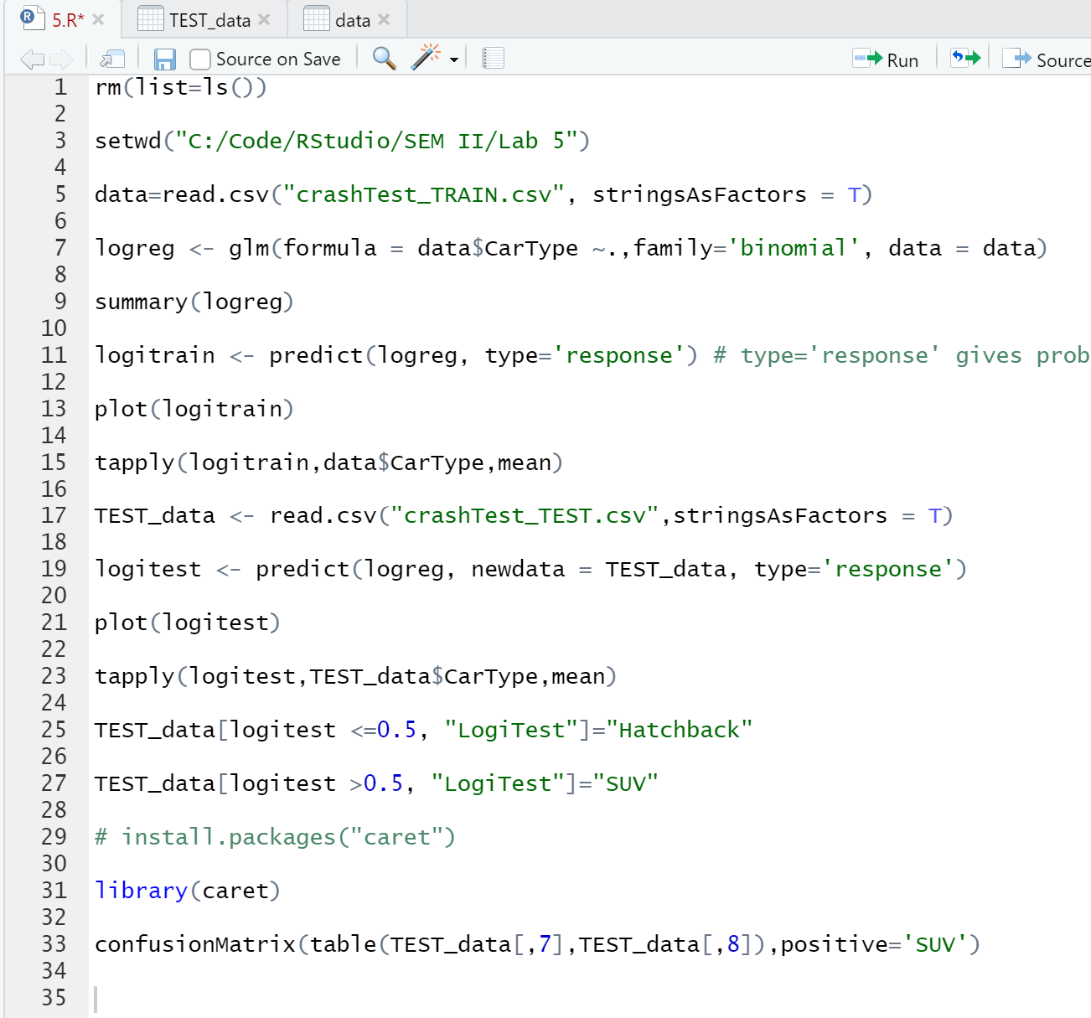

**OUTPUT**

